

John Keedwell GBCT. C.V.

November 2017

**Author.**

**Cinematographer. UAV Drone Pilot CAA approved UK**

**High Speed Camera Specialist.**

**Writer.**

**e-mail john@epicsacademy.com**

**Career summary**

Founder and facilitator 2013 Epics Academy

Tutor -High Speed cameras 2014 Ealing Met Film School

Tutor in video production 2014 Media First-Reading

Lead - Digital Imaging Department 2005 to 2013 Thatcham Research

Author - ***Get the Message now?!?*** 2013

Freelance Broadcast Cameraman 1993 to 2005 Various

Senior Broadcast Cameraman 1989 to 1993 Music Box

Freelance cinematographer 1984 to 1989 Various

Freelance camera assistant 1979 to 1980 BBC TV Manchester

Studio sound assistant 1979 BBC Radio Merseyside

**Key skills and achievements**

I have a wide ranging freelance career as a cinematographer filming in over 65 countries, in various climates and situations from -35C to +50C.

**Productions include:**

* **Navy Blue** - A 9 month journey around the globe with the Royal Navy in 1986. Filming from helicopters, ships and in high humidity conditions.
* **Cape to Cape** - A journey with a 15 year old Dennis fire engine from the Northern tip of Norway (Nordkapp) to Cape Aghulhas in South Africa, visiting Rwanda, Tanzania, Zimbabwe, Algeria and more.
* **Bon Jovi - Access All Areas** -on tour for 5 months following the rock band backstage on their 1989 world tour- A technically challenging 16mm film visiting Europe, Scandinavian countries, Japan, Russia, and throughout the UK. I co-produced and filmed the production, including customs carnets, transport, and other logistics for a three man crew travelling around the globe. We only had a 5 day pre-production period.
* **Festival au desert** was another highlight for logistics and technical challenges. This involved driving across the Sahara desert to a final desert location near Tomboctou in Mali, with HDCAM cameras and a full vision monitoring capability.
* **1990 Camel Trophy**, Siberia for 6 weeks. 16mm film. Filming Land Rovers being driven across a large part of Siberia from Bratsk to Irkutsk .
* **Pitch people** involved filming around the UK with many sales people, and showing their techniques. This film won a CINE Golden Eagle award and a Chris award in 2000.
* **Music Box** 5 years there working as the head of cameras. Filming many interviews and music gigs with many bands such as Robert Plant, Judas Priest, Aerosmith, Guns 'N Roses, Sepultura, Nirvana, Jamiroquai and many more.

**My book**

* In 2013 my book **Get The Message Now?!?** was published. It is a work of over a years writing and research, and examines the way we can utilise the modern video technology to convey your message to an audience.



**Recent Employment**

* I worked at Thatcham Research since July 2005, and I became Lead Digital Imaging Specialist filming with Phantom High speed cameras. I finished there in December 2013. My main responsibilities included working with highly specialist 1,000 frames per second High Speed cameras for vehicle crash testing and seat testing and communicating with EuroNCAP with post produced video and other visual material..
* In November 2012 Thatcham Research Crash facility became the first EuroNCAP High definition and High Speed accredited crash laboratory. The quality of the visual material was pivotal in gaining this accreditation.
* I was the sole driving force behind the introduction of the higher definition High Speed cameras at Thatcham, switching to HD Phantom cameras in 2005, and upgrading them in March 2013 to HD specification.
* I made many changes to the Media department workflow and technical quality of the output along with a DAM (or Digital Asset Management) solution so we could search the digital photography archive and find images quickly via keywords.
* I have continued to innovate and improve the facilities, the photographic visual style and print output. I was asked to design the Thatcham reception lighting, and my photographs have been printed and framed 1 metre square all throughout the Thatcham buildings.

**Writing and education**

* I also write technical articles for the British Cinematographer magazine, and I have been invited as a journalist by Band Pro in Los Angeles to cover their events there on several occasions. I also get invited to IBC in Amsterdam each year by different organisations.

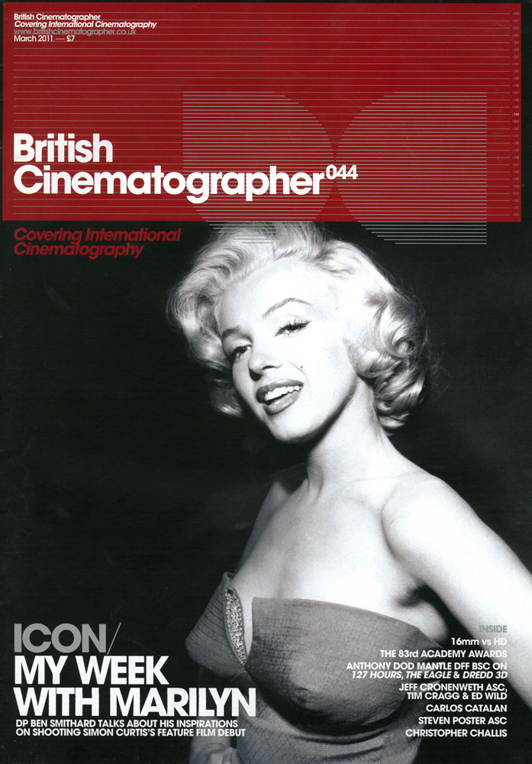 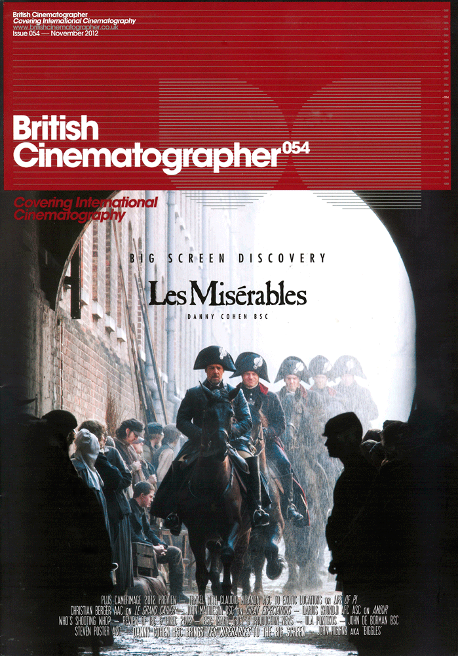

* I have also been invited and lectured to industry professionals on the benefits and methods of shooting in High Speed cameras. This was in Bristol in 2012 in conjunction with BECTU, Bristol University and Vision Research.
* GBCT ( Guild of British Camera Technicians) member

**Systems**

* Adobe Production Premium, including Photoshop, Premiere Pro, After Effects, Soundbooth
* Phantom High Speed cameras, Redlake High Speed cameras.
* Nikon, Mamiya, Olympus, Panasonic, Hasselblad photography, Sony HD Video.
* Arri, Aaton 16mm and 35mm film cameras.
* Avid, Sony Vegas, Sorenson Squeeze.
* MS Excel, Word, PowerPoint.

**Training and qualifications**

**Course/qualification Dates Education institution**

Adobe After Effects 2010 Media Training

BA ( Hons.) In Applied Photography Film and TV (2.1)

1981-1984 Harrow College

**Membership of professional bodies**

* **British Academy of Film and Television Arts ( BAFTA) voting member**
* **Guild of British Camera Technicians GBCT**
* **Guild of Television Cameramen (GTC)**
* **National Association of Photoshop Professionals ( NAPP)**
* **Broadcasting Entertainment Cinematograph and Theatre Union (BECTU)**

**Awards**

# **"Pitch people" won the** CINE Golden Eagle award and a Chris award in 2000.

**Interests**

I have numerous interests outside of work, including :

* Motor racing, music, cars, travel.
* I am passionate about cinema, photography and art

**Referees**

Andrew Hale- Principal Engineer at Jaguar Land Rover

07939 574253 panrider13@sky.com

David Amphlett -Product Development Manager, Broadcast Lighting at ROSCO -

07768 345712 David.Amphlett@rosco.com